2026-2027 FAITH FORMATION/YOUTH SCHEDULE

ELEMENTARY & MIDDLE SCHOOL FAITH FORMATION (Grades Pre-K – 8th)
Wednesday 4:30 p.m. - 5:45 p.m. Pre-K (4 year olds) through 6th grade
Wednesday 7:00 p.m. – 8:15 p.m. 1st through 8th grade
Sessions that have been cancelled due to weather, etc. will be made up by a home study format of lessons and homework.
(Eligible First Reconciliation and Eucharist candidates must take FF classes concurrently with both sacramental classes)
(Eligible Confirmation candidates must take youth group and/or FF classes concurrently with Confirmation classes)

2026 2027
AUGUST - registration JANUARY 6th
SEPTEMBER 9th (parents mtg & kids sessions) JANUARY 20th
SEPTEMBER 23rd FEBRUARY 3rd (parents mtg & kids sessions)
OCTOBER 7th FEBRUARY 17th
OCTOBER 21st MARCH 3rd
NOVEMBER 4th MARCH 17th
NOVEMBER 18th (parents mtg & kids sessions) MARCH 31st (parents mtg & kids sessions)
DECMEBER 2nd APRIL 7th
DECEMBER 16th APRIL 21st
MAY 5th

MIDDLE SCHOOL YOUTH GROUP (Grades 6th-8th)
(Program counts toward Faith Formation requirement - Students may register for both Faith Formation and Youth Group)
Meets Tuesdays 7:00-8:30pm in Rooms B & C and D & E
(Eligible Confirmation candidates must take youth group and/or FF classes concurrently with Confirmation classes)
2026 2027
AUGUST - Registration JANUARY 12th and 26th

SEPTEMBER 8th (Parents Meeting – no YG for kids) FEBRUARY 2nd and 16th
SEPTEMBER 22nd

OCTOBER 6th and 20th MARCH 2nd and 16th

NOVEMBER 3rd and 17th APRIL 6th, 20th

DECEMBER 1st and 15th MAY 4th

HIGH SCHOOL YOUTH GROUP (Grades 9th – 12th)
EVERY TUESDAY (except November, December and March) 7-8:30 pm in the St Clare Room
2026 2027
SEPTEMBER 8th (Parents Meeting – no YG for kids) JANUARY 5, 12, 19, and 26
SEPTEMBER 15, 22, and 29 FEBRUARY 2, 9, 16, and 23
OCTOBER 6, 13, 20, and 27 MARCH 2, 9, 16, and 30
NOVEMBER 3, 10, and 17 APRIL 6, 13, 20, and 27
DECEMBER 1, 8, 15, and 29 MAY 4

HOME STUDY
Please contact the Directors of Faith Formation and/or Youth Ministry for information. Home study is not available for sacramental preparation or grade level sessions during sacramental preparation years.
MORE (see next page)
2026-2027 FAITH FORMATION/YOUTH SCHEDULE CONT.

SACRAMENTAL PREPARATION CLASSES

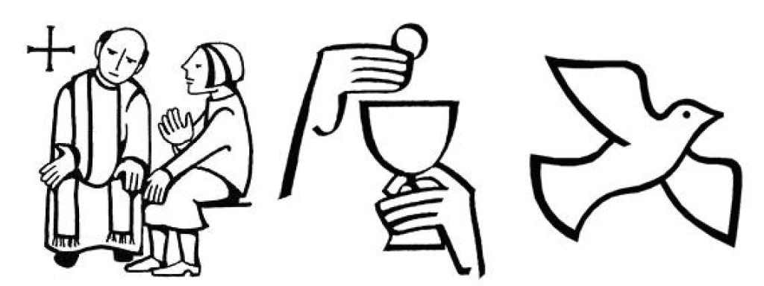
RECONCILIATION AND EUCHARIST CLASSES
Registration for Reconciliation and Eucharist sacramental preparation will take place at the same time as grade level study. Students should register for BOTH Reconciliation and Eucharist sacramental preparation in the same academic year. Students who will be in the second grade or older for the 2026-2027 school year are eligible to enroll in BOTH Reconciliation and Eucharist sacramental preparation. These students MUST have participated in and completed an eligible program last year. A grade level Faith Formation class MUST be taken concurrently with Reconciliation and Eucharist sacramental preparation.
Reconciliation and Eucharist sacramental preparation will be conducted in person following all Colorado State and Dept. of Health protocol. Parents are REQUIRED to attend Reconciliation and Eucharist sacramental preparation programs with their participating students. Plans will be in place if a synchronous learning model becomes necessary. Reconciliation and Eucharist sacramental preparation will be held the following Sundays, 3:30-4:45pm.
Reconciliation Sessions: September 13 & 27 – October 25 – November 8 – December 6 (5 sessions)
Reconciliation Service at 6pm: Thursday, December 10
Eucharist Sessions: January 10 & 24 – February 7 & 21 – March 7 & 21 – April 11 & 25 (8 sessions)
Eucharist Practice 3:00pm: April 25
Eucharist Masses: Saturday, May 1 at 5pm Mass or Sunday, May 2 at 10:30am Mass

CONFIRMATION CLASSES
Registration for Confirmation preparation will take place at the same time as grade level study. These classes meet on SUNDAY AFTERNOONS from 3:00 – 5:00 PM in the St Clare Room (unless otherwise noted). Students who will be in the 8th grade or older for the 2026-2027 school year are eligible to enroll in Confirmation preparation. These students MUST have participated in and completed an eligible program last year. A grade level Faith Formation or Youth Group class MUST be taken concurrently with Confirmation preparation. Service projects/opportunities will be made available for your candidate to meet his/her requirements. Please call the Youth Dir. for grades 9 & up.
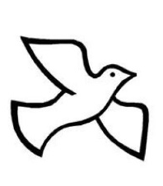
2026 2027
SEPTEMBER 13 Registration- Candidate /Parent Orientation* JANUARY 3
SEPTEMBER 20 FEBRUARY 7
OCTOBER 4 (Mini-Retreat 1-5pm) MARCH 7
NOVEMBER 15 APRIL 11
DECEMBER 6 APRIL 18
DECEMBER 13 Candidate & Parent/Sponsor potluck (6-8 pm) MAY 1 (Confirmation Retreat)
TBD Confirmation Practice ** TBD Confirmation Mass **
*Registration/Orientation MUST be attended by candidate AND parent (no exceptions) **NOTE: We will not know the date of our Confirmation Mass until we receive verification from the Bishop!

OCIC CLASSES (aged over 7 years who have not yet been Baptized)
OCIC preparation will be weekly on Wednesdays. Please contact the Directors of Faith Formation and/or Youth Ministry for further details.

